Intermediate Algebra Lecture C.3: A BRIEF Review of Graphing

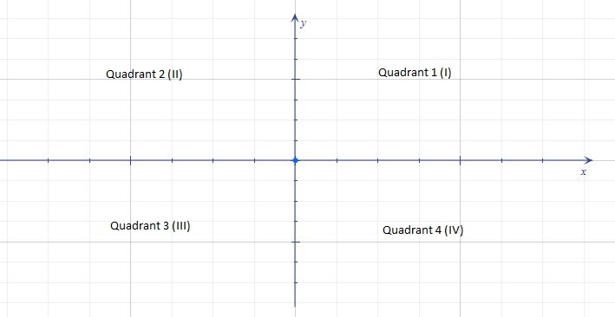

Linear Equations
7x-2y=4

The standard form of an equation is Ax + By = C. In this kind of equation, x and y are variables and A, B, and C are integers.
Two variables (two axis) graph is a straight line

To get standard form into slope intercept form isolate the y variable

Example
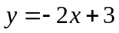 (slope intercept form)

When plotting a linear equation use T diagram, only need two points to create a line, use 3 to ensure that the line is correctly plotted

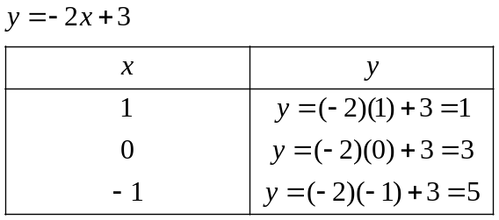

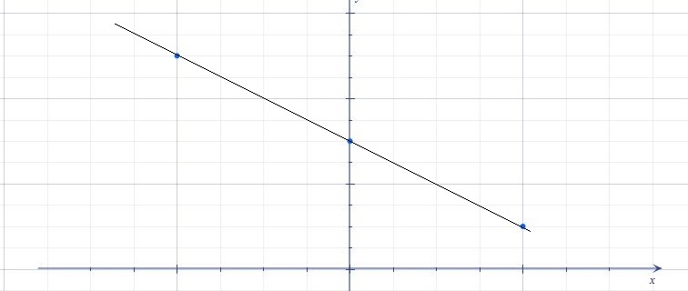

Where the Graph crosses the y axis is the y intercept (x=0)
Where the Graph crosses the x axis is the x intercept (y=0)

When the x term co-efficient is a negative number then the graph is fallen
When the x term co-efficient is a Positive number then the graph is Rising

Example
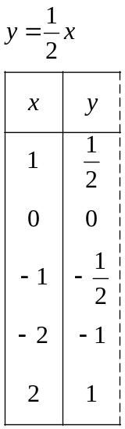

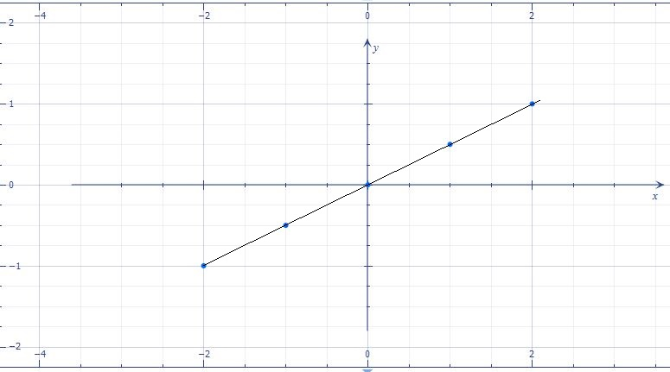

Horizontal and vertical lines
Eliminating a variable from a line equation (x or y) will give a Horizontal or vertical line

If you have a y variable the line will cross the y axis, the line is going to be horizontal. y=c
If you have a x variable the line will cross the x axis, the line is going to be vertical. x=c

